**Assignment No. : 1**

**TITLE**

TOMCAT SERVER installation

**OBJECTIVES**

1. Understand how to install tomcat server and set up environment variables

**PROBLEM STATEMENT**

Installation of TOMCAT Server and Configuration of it.

**OUTCOME**

*Students will be able to,*

1. Install TOMCAT Server and Configuration of it .

**SOFTWARE & HARDWARE REQUIREMENTS**

1. Java 7 or Later

2. Apache Tomcat Server

**THEORY-CONCEPT**

Web Application:

A web application runs over the Internet. Ex. eBay,Amazon ,Google, facebooketc

A webapp contains five components:

1.HTTP Server: Examples are- Google Web Server , Apache HTTP Server, Apache

Tomcat Server, Microsoft Internet Information Server (IIS) etc

2.HTTP Client (Web Browser): Examples are- Internet Explorer, Firefox, Google Chrome, Safari

3.Database:Examples are- MySQL, Apache Derby, MS SQL Server, SQLite, PostgreSQL, Commercial Oracle, IBM DB2, SAP SyBase, MS Access etc

4.Client-Side Programs: It can be written in HTML Form,VBScript, JavaScript, Flash etc.

5.Server-Side Programs: could be written in Java Servlet/JSP, ASP, PHP, Perl, Python, CGI, and others.

A web app is 3-tier (or multi-tier) client-server database application which run over the

Internet as shown in the following diagram,

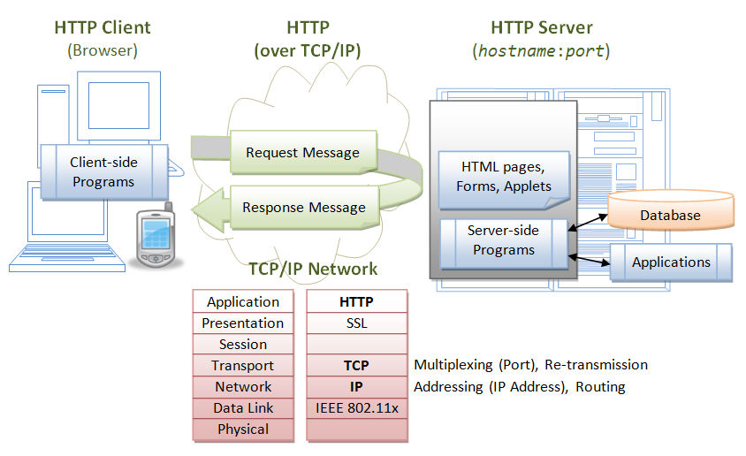

**Figure.1: Three-Tier Client-Server Architecture**

1. To start a webapp, A user, issues a URL request via a web browser (HTTP client), to

HTTP server.

2.The HTTP server returns an HTML form (client-side program), which is loaded into the client's browser.

3. The user fills up the query data inside the form and submits that form.

4. The client-side program sends the query parameters to a server-side program.

5.The server-side program receives the query parameters, queries the database based on these parameters, and returns the query result to the client-side program.

6. The client-side program displays the query result on the browser.

7.The process repeats for the next request.

**Apache tomcat**

Tomcat is an *open-source* project, under the "Apache Software Foundation" (which also provides the most use, open-source, industrial-strength Apache HTTP Server). The mother site for Tomcat is [http://tomcat.apache.or](http://tomcat.apache.org)g. Alternatively, you can find tomcat via the Apache mother site[: http://www.apache.o](:%20http://www.apache.o)rg.

**EXECUTION STEPS**

[1. Goto http://tomcat.apache.or](http://tomcat.apache.org)g

2. Select tomcat version 8 from left side list under Download option (tomcat 8) or select a link 32-bit/64-bit Windows Service Installer (pgp, md5, sha1, sha512)

3. Download and run ‘.exe ‘ file.

4. I preferred, installation of Tomcat at C:\Program Files (x86)\Apache Software

Foundation

5. Use the default settings and provide a password that you will remember.

6. Now you will find the Tomcat installed at C:\Program Files (x86)\Apache Software

Foundation\Tomcat 8.0

**How to Run Tomcat**

Following are the steps to check whether Tomcat has been installed successfully or not-

1. Find start program in the Programs Menu. Look under Apache Tomcat and select "Start Tomcat" or “startup.bat”.

2. Open any web browser and type in the given URL:

o [http://localhost:80](http://localhost:8080/)80/

Now, you will see the Tomcat home page, which is provided by the Tomcat Web server running on your computer. To shut down your server and remove the Console window, select "Stop Tomcat" in the same menu of where you selected "Stop Tomcat".

T o m c a t 's D i r e c t o r i e s

It contains the following sub-directories:

• bin: It contains the binaries; startup script (startup.bat for Windows and startup.sh for Unix and Mac OS), shutdown script (shutdown.bat for Windows and shutdown.sh for Unix and Mac OS), as well as other binaries and scripts.

• con f: It contains the system-wide configuration files such as server.xml, web.xml, context.xml, and tomcat-users.xml.

• lib: It contains the Tomcat's system-wide JAR files, which can be accessible by all webapps. We can also place external JAR file (such as MySQL JDBC Driver).

• lo gs : It contains log files of Tomcat. Also, you can check error messages here.

• web ap ps : It contains the webapps to be deployed. You can also place the WAR (Webapp Archive) file for deployment here.

• wor k : Tomcat's working directory used by JSP, for JSP-to-Servlet conversion.

• temp : Temporary files are stored in this directory.

How to set a path for Windows

Assuming you have installed Java in C:\Program Files (x86)\Java\jdk 1.7.0directory −

• Right-click on 'My Computer' and select 'Properties'.

• Click the 'Environment variables' button under the 'Advanced' tab.

Now, alter the 'Path' variable so that it also contains the path to the Java executable. Example, path set to C:\Program Files (x86) \Java\jdk1.7.0\bin

OR

through command prompt you can set the path by following command

set path=C:\Program Files (x86) \\Java\jdk1.7.0\bin

Step 1: Download the installation package

The first step is to download the XAMPP package for Linux from the official Apache Friends website: <https://www.apachefriends.org/index.html>

**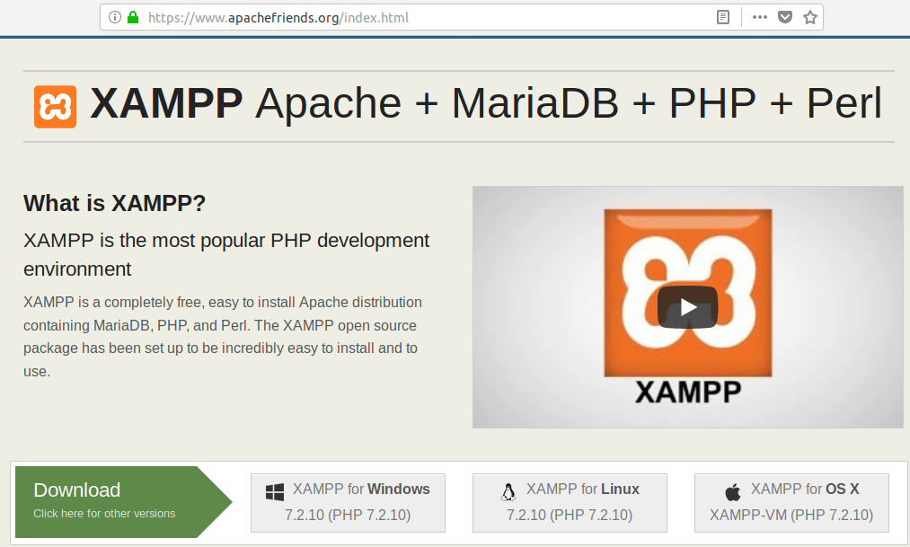**

Click on the XAMPP for Linux option after which you will be prompted to Run the package or Save it to your system. We recommend downloading the package by clicking the Save File option. After which, your downloaded file will be saved to the Downloads folder by default.

### Step 2: Make the installation package executable

We will install the package through the Ubuntu command line, The Terminal. In order to open the Terminal, either use the Dash or the **Ctrl+Alt+T** shortcut. After the Terminal is open, you need to move to your Downloads folder to access the file.

Move to the Downloads folder by using the following command:

$ cd /home/[username]/Downloads

The installation package you downloaded needs to be made executable before it can be used further. Run the following command for this purpose:

$ chmod 755 [package name]

Example:

$ chmod 755 xampp-linux-x64-7.2.10-0-installer.run

**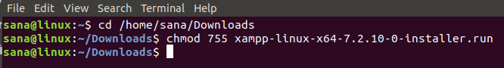**

Now the install package is in an executable form.

### Step 3: Confirm execute permission

It is important to verify if the package can be executed by the current user. The execute permission can be checked through the following command:

$ ls -l [package name]

Example:

$ ls -l xampp-linux-x64-7.2.10-0-installer.run

**C:\Users\abc\Desktop\wt\How to Install XAMPP on your Ubuntu 18.04 LTS System_files\word-image-2.png**

The -rwxr output shows that the file can be executed by the user whose name is also mentioned in the output.

### Step 4: Launch the Setup Wizard

As a privileged root user, run the following command in order to launch the graphical setup wizard.

$ sudo ./[package name]

Example:

sudo ./xampp-linux-7.2.10-0-installer.run

**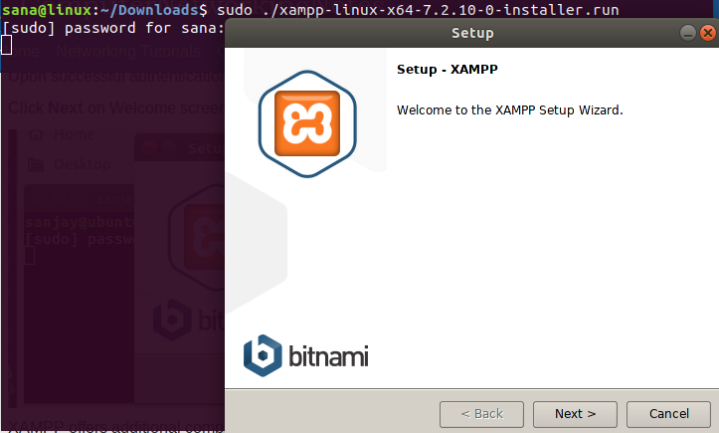**

### Step 5: Launch XAMPP through the Terminal

In order to launch XAMPP through your Ubuntu Terminal, enter the following command as root:

$ sudo /opt/lampp/lampp start

**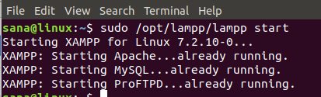**

### Step 6: Verify Installation

After you have installed XAMPP on your Ubuntu system, it is good practice to verify the installation. To do so, enter the following URL in your FireFox browser:

http://localhost

The following webpage verifies that XAMPP is successfully installed and running on your system:

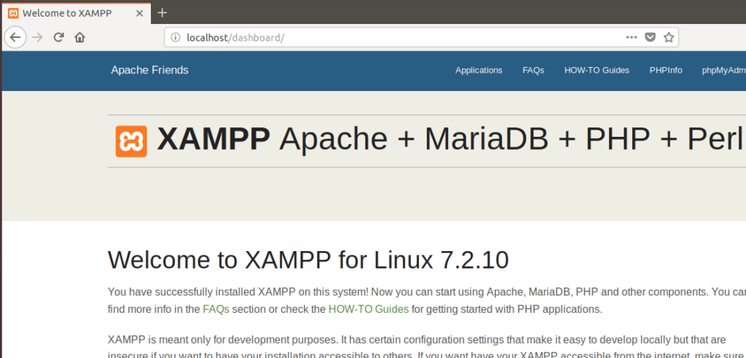

**CONCLUSION / ANALYSIS**

Hence, we have learned how to install and configure tomcat server.

**ORAL QUESTIONS**

1. What is Tomcat?

2. What is the tomcat default port?

3. What is the servlet container life cycle?

4. What services are provided by Tomcat?

5. Explain directory structure of tomcat.